2303A51581
Batch-10
LAB ASSIGNMENT-1.4
TASK-1
#PROMPT
Write a program to check whether the number prime number or not without using function.
#CODE
num = int(input("Enter a number: "))
if num > 1:
for i in range(2, int(num**0.5) + 1):
if (num % i) == 0:
print(f"{num} is not a prime number")
break
else:
print(f"{num} is a prime number")
else:
print(f"{num} is not a prime number")
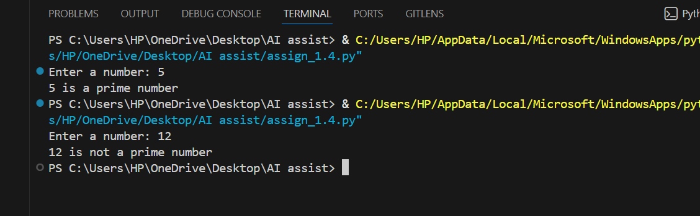
#OUTPUT
#ANALYSIS
This program checks if a number is prime by testing divisibility from 2 up to √n. If any number divides it, it’s not prime; otherwise, it is prime. This makes the check efficient and accurate.
#TASK-2
#PROMPT
Optimize the above code using function.
#CODE
def is_prime(n):
if n <= 1:
return False
for i in range(2, int(n**0.5) + 1):
if n % i == 0:
return False
return True

if __name__ == "__main__":
number = int(input("Enter a number: "))
if is_prime(number):
print(f"{number} is a prime number")
else:
print(f"{number} is not a prime number")

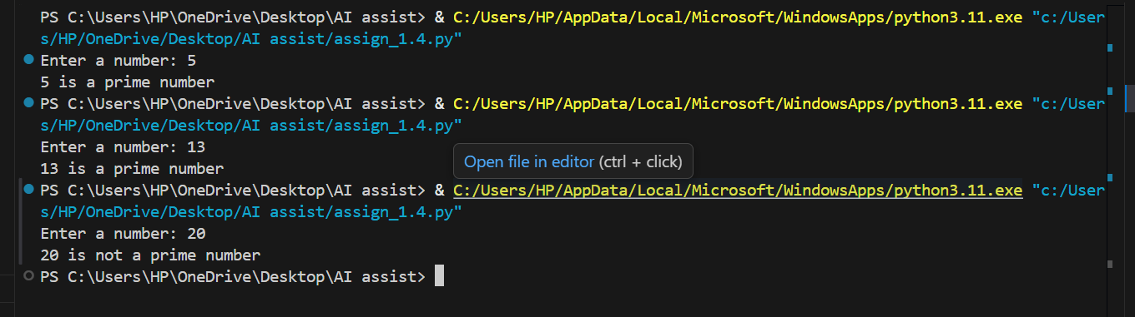
#OUTPUT
#ANALYSIS
This program defines a function is_ prime () that checks whether a number is prime by trying to divide it by all numbers from 2 up to the square root of the number. If any division gives remainder 0, the function returns False (not prime). If no divisor is found, it returns True (prime). The main part of the program takes a number from the user, calls the function, and prints whether the number is prime or not.
TASK-3
#PROMPT
Fibonacci series without using function.
#CODE
n_terms = int(input("How many terms? "))
n1, n2 = 0, 1
count = 0
if n_terms <= 0:
print("Please enter a positive integer")
elif n_terms == 1:
print("Fibonacci sequence up to", n_terms, ":")
print(n1)
else:
print("Fibonacci sequence:")
while count < n_terms:
print(n1)
nth = n1 + n2
n1 = n2
n2 = nth
count += 1
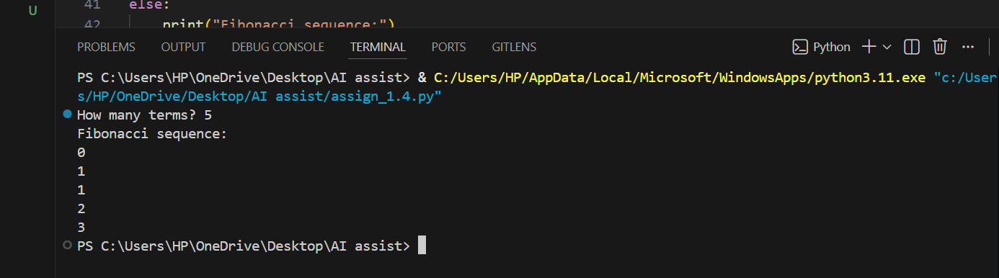
#OUTPUT
#ANALYSIS
This program prints the Fibonacci sequence using a while loop. It starts with 0 and 1, then keeps adding the last two numbers to get the next term. The loop runs until the required number of terms is printed.
TASK-4
#PROMPT
Optimized the above code using function.
#CODE
def fibonacci(n):
sequence = []
a, b = 0, 1
for _ in range(n):
sequence.append(a)
a, b = b, a + b
return sequence
if __name__ == "__main__":
terms = int(input("How many terms? "))
if terms <= 0:
print("Please enter a positive integer")
else:
print("Fibonacci sequence:")
for num in fibonacci(terms):
print(num)
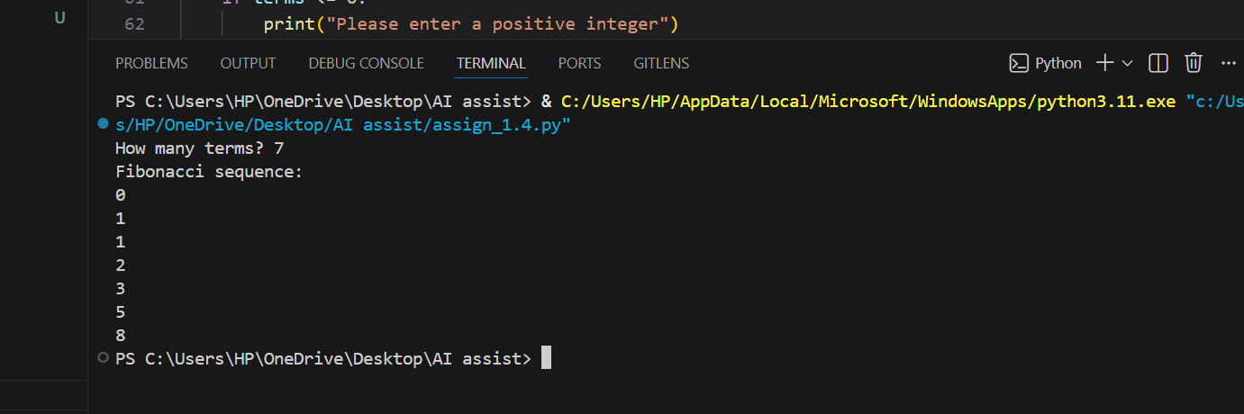
#OUTPUT
#ANALYSIS
This program generates the Fibonacci sequence using a function. It starts with 0 and 1, then repeatedly adds the last two numbers to create the next term. Each value is stored in a list, making it easy to reuse or print. The for loop ensures exactly n terms are generated, and input validation prevents invalid entries.
TASK-5
#PROMPT
Write a function to find the longest common prefix string amongst an array of strings. If there is no common prefix, return an empty string.
#CODE
def longest_common_prefix(strs):
if not strs:
return ""
prefix = strs[0]
for s in strs[1:]:
while s[:len(prefix)] != prefix and prefix:
prefix = prefix[:-1]
return prefix
if __name__ == "__main__":
string_list = ["flower", "flow", "flight"]
result = longest_common_prefix(string_list)
print(f"The longest common prefix is: '{result}'")
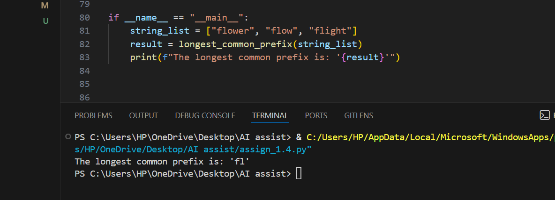
#OUTPUT
#ANALYSIS
This program finds the longest common prefix by comparing strings and shortening the prefix until it matches all. It’s simple, efficient, and handles empty lists correctly.

